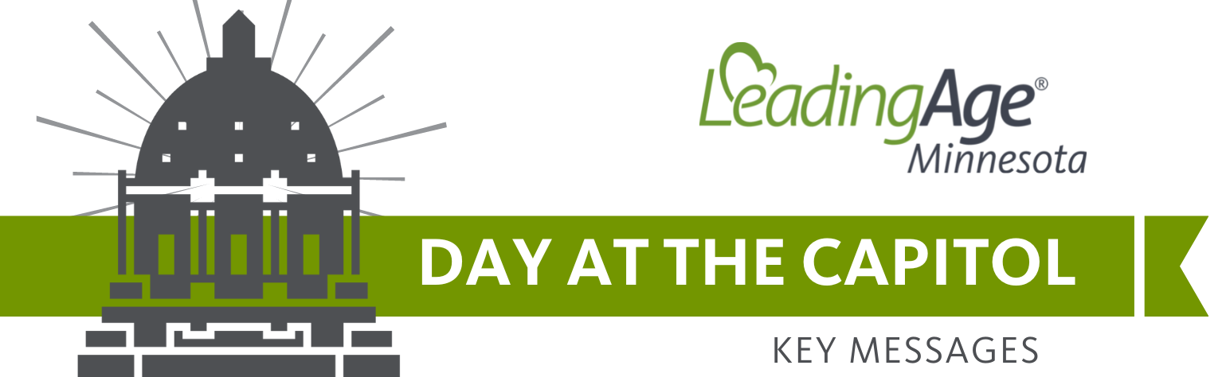
KEY MESSAGE: The staffing shortage in senior care is a crisis affecting older adults and families in every corner of the state. Only lawmakers can address this crisis and ensure access to care for all seniors.
There are nearly 20,000 open caregiver positions in Minnesota’s long-term care communities. That means seniors don’t have access to the care they need, when and where they need it.

PAYMENT BILL
PROBLEM: Minnesota’s seniors are being denied the care they need because there aren’t enough caregivers. State leaders set reimbursement rates for care, so the ability to recruit caregivers depends on the state’s programs. Current rates do not provide enough money for caregivers to make a living wage.
SOLUTION: Invest in seniors and their caregivers through a Medicaid reimbursement system that better reflects the true cost of care today.
WHAT THE BILL DOES:
- Provides a direct rate increase for nursing homes ($52/day)
- Makes categorical moves of select staff from price to cost to facilitate wage increases
- Addresses the 21-month delay in reimbursement for nursing homes
- Fully funds the state’s Medicaid waivers that are intended to cover the costs of caring for seniors
ASK FOR YOUR LAWMAKERS:
FOR YOUR SEN.: Support SF 780. This bill has received a hearing in the Senate Human Services Committee and has been laid over for possible inclusion in the omnibus bill. Please ensure that any human services spending bill before you has $1 billion for seniors’ caregivers. That is enough to increase our frontline workers’ pay by an average of $5/hour.
- If you are meeting with Hoffman, Abeler, Kupec, Hauschild, or Farnsworth, thank them for co-sponsoring the bill.
- If you work in a nursing home: We have very serious concerns with SF 1621, which would create additional staffing mandates for nursing homes. We agree with the goal to increase wages and staff in our settings, but this bill doesn’t provide money to pay for them. Please encourage Sen. Pappas to work with nursing home stakeholders to address our concerns.
FOR YOUR REP.: Support HF 733. This bill has received a hearing in the House Human Services Finance Committee and has been laid over for possible inclusion in the omnibus bill. Please ensure that any human services spending bill before you includes $1 billion for seniors’ caregivers. That’s enough to increase our frontline workers’ pay by an average of $5/hour.
- Last year, the House’s proposed investment would have only raised wages by $2/hour. We can and must do better with a $17 billion surplus.
- If you work in a nursing home: We have very serious concerns with HF 908, which would create additional staffing mandates for nursing homes. We agree with the goal to increase wages and staff in our settings, but this bill doesn’t provide money to pay for them. Please encourage Rep. Agbaje (Ahg-bajay) to work with nursing home stakeholders to address our concerns.
- If you are meeting with Edelson, Brand, Elkins, Bierman, Zeleznikar, Dotseth, Acomb, Garofalo, Engen, Stephenson, Moller, Hemmingsen-Jaeger, Torkelson, Daniels, Davis, Freiberg, Richardson, or Wolgamott, thank them for co-sponsoring the bill.

ASSISTED LIVING BILL
PROBLEM: When the assisted living statute (144G) was enacted, stakeholders knew that creating and implementing the new laws would be a continuous improvement process. The current licensure law has incredibly rigid requirements that place additional barriers to getting caregivers to work, allowing them to work to the top of their scope and compensating them fairly for serving our seniors. Meeting the requirements of this law makes the ability to offer affordable services more challenging than ever, especially for small providers.
SOLUTION: Make limited and strategic revisions to Minnesota’s assisted living statutes to improve the affordability of assisted living services.
WHAT THE BILL DOES:
- Allows LPNs to conduct 90-day reassessments not initiated by a change in condition, which is within the current LPN scope of practice and alleviates our RN shortage issue
- Makes some exceptions to the food code requirements for small residential settings of 6 or fewer residents
- Provides portability of orientation training for staff who work at more than one location owned/operated by the same organization
- Exempts independent living residents not receiving assisted living services from needing an individual abuse prevention plan
- Modifies some physical plant and life safety standards to align with existing building code requirements for housing 16 or fewer residents
ASK FOR YOUR LAWMAKERS:
FOR YOUR SEN.: Support SF 1969. The bill makes limited and purposeful changes to Minnesota’s assisted living statutes. Help us ensure that assisted living is accessible and affordable for Minnesota’s seniors.
- If you are meeting with Senators Housely, Abeler, or Hoffman, thank them for co-authoring the bill.
FOR YOUR REP.: Support HF 2080. The bill makes limited and purposeful changes to Minnesota’s assisted living statutes. Please ask Chair Noor to give it a hearing in his committee.
- If you are meeting with Representatives Noor or Zeleznikar, thank them for co-authoring the bill.

PACE BILL
PROBLEM: Minnesota’s seniors have a right to care and housing in their communities. We must do everything we can to encourage innovation to serve the growing population of seniors. It’s the state’s responsibility. Yet, the innovative and comprehensive program called PACE (Program for All-Inclusive Care for the Elderly), which has been implemented in over 30 states and serves comprehensive, person-centered, cost-effective care for some older adults, isn’t used in Minnesota.
SOLUTION: Conduct a PACE rate study, a critical step before Minnesota can invest in PACE and the seniors who would benefit from the integrated model of care.
WHAT THE BILL DOES:
- Directs the Department of Human Services (DHS) to conduct an actuarial study that determines the capitated rate for providing PACE in Minnesota
- Provides one-time funding of $265,000 to conduct the study and cover agency staff time to develop implementation steps
ASK FOR YOUR LAWMAKERS:
FOR YOUR SEN.: Support SF 1640, a bill to help bring person-centered comprehensive care for the elderly to Minnesota. It has bipartisan support and was included in the Health and Human Services Omnibus bill last session.
- If you are meeting with Senators Morrison, Housely, Abeler, or Hoffman, thank them for co-authoring the bill.
FOR YOU REP.: Support HF 1596, a bill to help bring person-centered comprehensive care for the elderly to Minnesota. It has bipartisan support and was included in the Health and Human Services Omnibus bill last session.
- If you are meeting with Representatives Reyer, Her, Franson, or Zeleznikar, thank them for co-authoring the bill.

